Project Report

|  |  |
| --- | --- |
| Project Title | Problem Manage a Server Outage Scenario & an Issue & Change Request Management System |
| Qualification Name (NICF) | Advanced Certificate in Software Applications (Development and Deployment) |
| Product Name | NICF-Capstone Project using Java |
| Module Name (NICF) | NICF-Capstone Project using Java |

|  |  |  |  |
| --- | --- | --- | --- |
| Student name | | Assessor name | |
| Ida Bagus Ketut Yoghantara | |  | |
| Date issued | Completion date | | Submitted on |
| 10 October 2022 |  | |  |
|  | |  | |
| Project title | Student Registration Form Development | | |

|  |
| --- |
| Learner declaration |
| I certify that the work submitted for this assignment is my own and research sources are fully acknowledged.  Student signature:  Date: |

Content

1. Project background
2. Project Objectives
3. Project Requirement Specifications
4. Task 1
5. Task 2
6. Task 3
7. Task 4
8. Task 5
9. Task 6
10. Task 7

Project Background

This Project is used for Summative Assessment of student in the “NICF-Capstone  
Project using Java” of the NICF Course “Advanced Certificate in Web Development”  
In this project you must design, plan & test the community portal website you have  
developed in module 5 “NICF-Web Development Foundations”.

You have been approached by ‘ABC Jobs Pte Ltd’ as a website developer to manage a problem they are facing. They have a website for managing their community of developers. The website goes down intermittently. You also need to explore how to streamline the incidence & enhancement management to reduce such problems from reoccurring. The scope of this project is to problem manage the situation and come up with a solution.

Project Objective

**Project Outcomes & Deliverables**

You should perform all the tasks in the Project Task List and prepare the following  
during the project:

* Briefly explain different types of testing which you will undertake
* Test Schedule Document
* Phase test plan
* Execute test scripts and verify the results
* Prepare a Project Report as per pre-defined template
* Prepare a Project Presentation as per pre-defined template
* Prepare a Testing Document

**Scope of the Project:**

* Explain principles of problem management across its lifecycle.
* Use various tools, process and technologies to facilitate problem identification, investigation, analysis & resolution
* Explain various steps to investigate & diagnose problems.
* Prioritize & Categorize change requests.
* Prepare a solution to address the root cause of the problem.
* Document & monitor the problems
* Explain best practices in documenting problems.

Tools & platform used

* Diagram.net  
  diagrams.net is a free and open-source cross-platform graph drawing software developed in HTML5 and JavaScript. Its interface can be used to create diagrams such as flowcharts, wireframes, UML diagrams, organizational charts, and network diagrams.
* Microsoft Word  
  Microsoft Word is a word processing software developed by Microsoft.
* Microsoft Power Point  
  Microsoft PowerPoint is a powerful slide show presentation program. It is a standard component of the company's Microsoft Office suite software, and is bundled together with Word, Excel, and other office productivity tools. The program uses slides to convey information rich in multimedia.

Project Requirements Specifications

* Functional Requirements

**Software Programmer (Users)**

|  |  |  |
| --- | --- | --- |
| **No** | **Page Name/ Function Name** | **Requirement** |
| 1 | Registration | This page is for user to register to the website and save their data to database |
| 2 | Login user | Used for user to login to the website |
| 3 | Forgot password | Used for user to get their forgotten password by resetting their old password by email confirmation |
| 4 | Search user | Used for searching another user and view their profile page |
| 5 | Update/Edit profile page | Used for user to update or edit their profile page information |
| 6 | Change password | Used for user to change their account password |
| 7 | Posting Thread | Used for user to posting thread for discussion |
| 8 | Comment Thread | Used for user to comment in thread |
| 9 | Apply job | Used for user to applying to a job that exist in the website |

**Administrator**

|  |  |  |
| --- | --- | --- |
| **No** | **Page Name/ Function Name** | **Requirement** |
| 1 | Login admin | Used for admin to login as administrator of the website |
| 2 | Dashboard | Administrator page to manage all the users of the website, this page includes add, view list user, edit user, delete user, send bulk email, posting job and accepting user to the job functionality. |
| 3 | Add user | Used for adding new user to the application from admin side |
| 4 | Edit user | Used for editing user data |
| 5 | Delete user | Used for deleting user data |
| 6 | Posting jobs | Used for posting jobs opportunity to the software programmers/user of the website |
| 7 | Accept user for job | Used for accepting user for the job they applying |

* Non-Functional Requirements

|  |  |  |
| --- | --- | --- |
| No | Requirements | Purpose |
| 1 | Performance | Define how well the application to accomplishes certain functions under specific conditions |
| 2 | Availability | Describe how likely the system is accessible for a user at a given point of time |
| 3 | Security aspect | Assures all data inside the ABC Database or its part will be protected against malware attack or unauthorized access |
| 4 | Database backup and recovery | To protect the database against data loss and reconstruct the database after data loss |
| 5 | Compatibility | Defines how a system can coexist with another system in the same environment. |
| 6 | **Localization** | Defines how well a system or its element falls in line with the context of the local market |
| 7 | Scalability | Assesses the highest workloads under which the system will still meet the performance requirements. |

Task 1

Task Statement:

1. Briefly explain principles of problem management with an example across its  
   lifecycle.
2. Include it as part of Project Presentation.

Solution:

* What is Problem Management?

Problem management is the collection of processes and actions in charge of controlling the lifecycle of all problems that may arise in an IT service. It also employs preventative techniques to find underlying causes and stop issues before they start.

Problem management aims to stop future occurrences of problems or incidents if they have already happened. It also entails figuring out the best strategy to get rid of the underlying issue. If the issue cannot be avoided, an efficient problem management procedure will help lessen its negative effects on the company.

* Principles of Problem Management
  1. Problem Identification

A problem can be detected within an incident report or an analysis of an existing incident. When the reason for an occurrence or series of incidents is unclear, it is most likely. In order to prevent future service interruptions, proactive problem detection is very important.

* 1. Problem Logging

It's crucial to document issues for later reference. Details about the problem, such as its kind, description, related events, category, user information, status, resolution, and closure, must be recorded. To tag known problems and manage them in a database, this information is essential.

* 1. Problem Investigation

An investigation into the root cause of a problem also depends on the severity and urgency of the problem. Common investigation techniques include reviewing the Known Error Database (KEDB) in an effort to find similar problems. Then, the best course of action is determined to resolve the problem.

* 1. Resolution

Once resolved and the solution is determined, it can be implemented using a standard change procedure. It is also important to ensure service recovery. In order to fix the problem permanently, a new change has to be raised. Change Management handles the evaluation, planning, and execution of changes.

* 1. Review

During this stage, it is important to review the resolution of the problem, and its impact on the business as well as carry out a risk analysis. This ensures that the problem management process is carried out smoothly and continually improved for the future. This review is recorded as well as shared with relevant teams and individuals.

* Problem Management Example

1. Problem Identification

Error from the development process, the root cause is “Neither BindingResult nor plain target object for bean name ‘searchUser’ available as request attribute”

Screen shot:

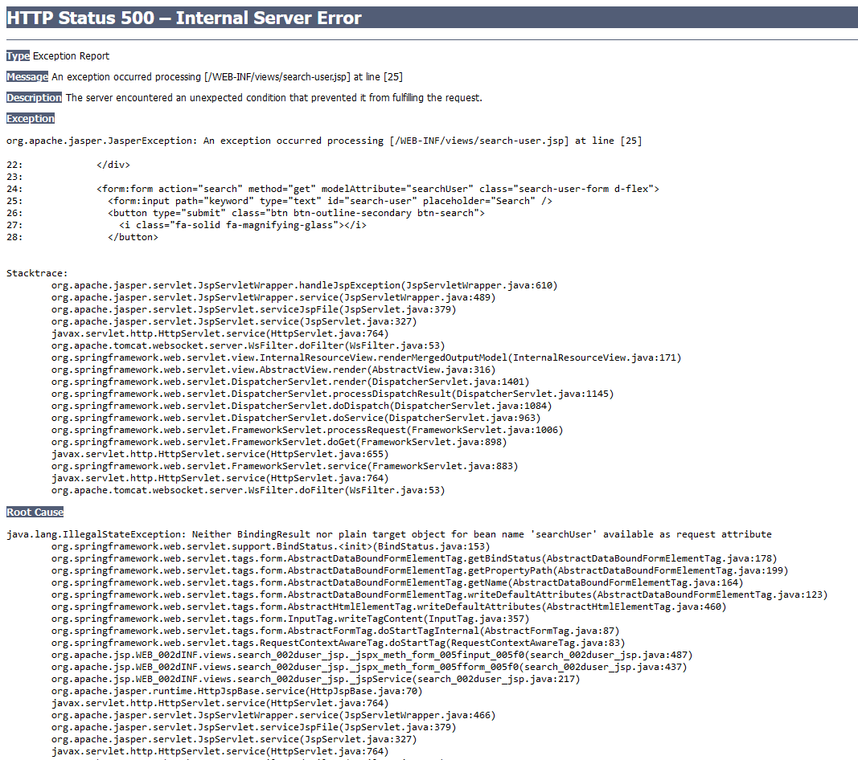

1. Problem Logging

|  |  |  |  |
| --- | --- | --- | --- |
| No | Where | Date | Root Cause |
| 1 | Search Controller | 2 October 2022 | Neither BindingResult nor plain target object for bean name ‘searchUser’ available as request attribute |

1. Problem Investigation

It likely because the object model hasn’t mentioned in the controller

1. Resolution

Create object instance of SearchForm, add object to ModelAndView and named it ‘searchUser’

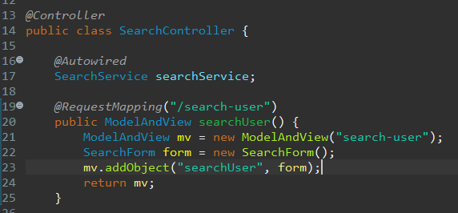

Task 2

Task Statement:

1. Explain briefly various tools, process & technologies to facilitate problem  
   identification, investigation, analysis & resolution.
2. Include it as part of Project Presentation.

Solution:

* Problem Identification

Techniques = Issue Tracking System

Tool = Excel Sheet

Using an Excel sheet to make a tracking document template is an important tool for problem identification.

Process:

1. Receive a problem report
2. Verify the problem
3. Logging the problem issue
4. Resolving the problem
5. When it’s resolved, it will be remarked as resolved in the issue tracking system

|  |  |  |  |  |  |  |  |  |  |  |
| --- | --- | --- | --- | --- | --- | --- | --- | --- | --- | --- |
| Issue Identification and Tracking Document | | | | | | | | | | |
| Created By: | | | Yoghantara | | Last Update By: Yoghantara | | |  | | |
| Date Created: | | | 14 October 2022 | | Last Revision Date: 14 October 2022 | | |  | | |
| Issue No. | Issue Description | Issue Type | Identified By | Date Identified | Issue Assigned To | Target Resolution Date | Priority | Status | Date Resolved | Resolution Description |
| 1 | The post comment on the thread not connected to the database | Technical Issues | Software Tester Team | 13 October 2022 | Software Development  Team | 15 October 2022 | High | Resolved | 14 October 2022 | Adding the service method to the controller so the appropriate functionality works |

* Problem Investigation

Techniques = Root Cause Analysis

Tool = Fish Bone

Process:

1. Define the problem statement
2. Find the root cause
3. Fix the root cause
4. Finalize solution

* Problem Resolution

Techniques = Known Error Database

Tool = Excel Sheet

Using an Excel sheet to make a tracking document template is an important tool for problem identification.

Process:

1. Adding known error records
2. Create a known error record with the symptoms and resolution details
3. Accessing known error records
4. Search KEDB and apply fix
5. Deleting known error records
6. Permanent solution implemented

Task 3

Task Statement:

1. Explain briefly various steps you will take to investigate & diagnose problems.
2. Include it as part of Project Report.

Solution:

* Investigate Problem

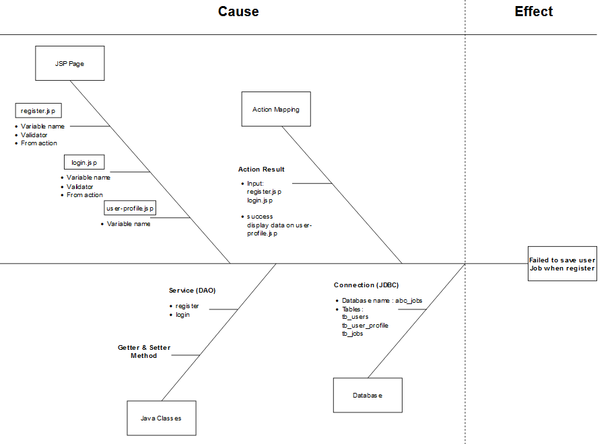

* Diagnose Problem

Diagnosing the root cause:

* “Value not present”
* It most likely because the jsp form value for job is not present any value

1. Task 4

Task Statement

1. Briefly explain how you will prioritize, categorize incident & change requests for  
   the application according to their severity, frequency or potential implication.
2. Include it as part of Project Presentation.

Solution

Prioritize and Categories problems:

* Tier 1: Low priority issues  
  The first tier is for basic or minor problems.

Example: Typo for some words on the website

* Tier 2: Medium priority issues

The second tier is the major problems

Example: Register page is not working and not saving to the database

* Tier 3: High priority issues

The third tier is the critical problems

Example: Website server down, Hacker attacks the website

1. Task 5

Task Statement

1. Explain about solution you will implement to address the root cause of the  
   problem and avoid their reoccurrence.
2. Include it as part of Project Presentation.

Solution

Case problem: User comment on the thread post not showing properly after the user posting a comment.

Solution:

1. Check the controller and service method that fetching the comments database
2. Fix the appropriate function/method
3. Test the functionality
4. After the problem is resolved, write down the problem in the table KEDB to avoid their reoccurrence

|  |  |  |  |  |  |  |
| --- | --- | --- | --- | --- | --- | --- |
| Known Error Database | | | | | | |
| **Ticket no.** | Issue Description | Issue Type | Root Cause | Workaround | Status | Date Resolve |
| 1. | The comment on the thread post not fetching properly | Technical Issues | There is missing DAO code to connect to the database | Correcting code for DAO linked databases | Resolved | 14 October 2022 |

1. Task 6

Task Statement:

1. Explain briefly any systems you will implement.
2. Include it as part of Project Presentation

Solution

Systems that will be implemented:

1. Apply Job

Users (Software Programmer)

1. List Job Page

* Listing all the jobs that exist on the website
* All website users can see this page

1. Apply Job functionality

* User that login to the website and currently don’t have a job can apply to the job

1. Apply Job history

* History for User that applying for one or more jobs on the website
* Showing the status of the job applications, user can know they are accepted for the job or turned down for the job

1. Search Job functionality

* Users can search for the job that exist on the website
* The search functionality support searching the jobs name, company, job level, and job level

1. User Job Page

* Showing the user job

Admin

a. Manage jobs

* Managing the jobs (Post, Edit, and Delete)
* Accept job applicants
* Decline job applicants

1. Threads
2. List Thread

* List of all the thread

1. Search Thread

* User can search for the specific thread
* The search functionality support searching the thread title, thread first tag and second tag

1. Post Thread

* User can post thread after they login to the website

1. Edit Thread

* User can edit their post

1. Read Thread

* User can read all the thread post

1. User Thread

* Login user list thread

1. Comment Thread

* Comment to the thread for discussing to other user or asking question

1. Task 7

Task Statement:

1. Briefly explain any best practices and industry standards in documentation  
   related to problem management.
2. Include it as part of Project Report.

Solution

Best Practices and Industry Standards for Problem Management:

1. Solved problems need to be recorded in Known Error Database

You have a 'Known Error' when you have put your investigative skills to the test and identified the root cause of the problem. Known problems, like incidents, should be kept in a separate area from the problem. Simply put, it enables you to be more dynamic in your categorization. This allows you to recategorize an error to something more appropriate after an investigation.

1. Clients should be separate from the person handling the incident

It's tempting to keep everything in a hold-all. When dealing with a call, look for a location that can serve as a one-stop shop. Separating problems from incidents and logging them in their own dedicated space, on the other hand, can help to improve your processes.

1. Having a problem manager

Having someone that is ultimately responsible for Problem Management can vastly help to improve your overall process.

1. Let your operators contribute: Share knowledge

Having a manager is great, but collaboration is key. Invite your team to make the most of their knowledge and experience by allowing them to contribute to Problem Management. This can add some interesting variation to their roles, and can help you to identify a root cause more quickly if you have keen colleagues who are good at detecting issues.